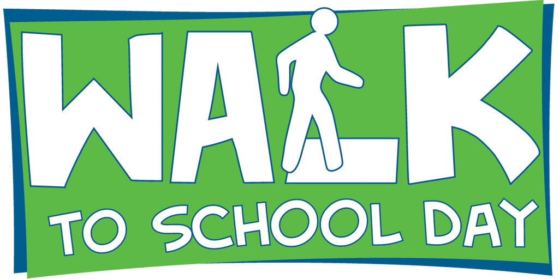
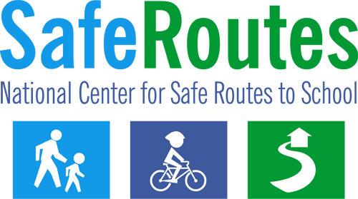

Walk to School Day News Release
The following news release template can be tailored to inform local media about International Walk to School Day (each year in October) or other Walk to School events being organized throughout the year.

Using the Template

- Fill in the bracketed areas with your organization/event information.
- Logo: Use the Walk to School Day logo or replace it with your own program logo. You may want to print the news release on your organization’s letterhead.

- Contact Information: Choose a point person for the news release who will be available once the release is distributed and throughout the event. Use the contact phone number that has the greatest likelihood of reaching the person.
- Length: The ideal news release is no longer than one page in length.
- Identify Media Contacts: Find tips on contacting the media at www.walkbiketoschool.org/get-set/promote-the-event/press-releases.
- Distribution: A few days or the day before the event, distribute the release to local media contacts (television, radio, and newspaper through email, fax, mail or hand-delivery).

- Materials: Have copies of the news release available at the event. In addition, you may also compile a press kit, including fact sheets, backgrounders and biographies.
.

Scroll down to pages 2 and 3 for the news release.

FOR IMMEDIATE RELEASE  [Release date] |  | CONTACT: [Name] [Phone number]  [Email address]
[City, county, area] school(s) to celebrate
International Walk to School Day on [Month Day], [Year]

[CITY, STATE] ([Date]) – [Name of school, participating organizations, etc.] in [city] will join schools from around the world to celebrate International Walk to School Day on [Month Day, Year].

Approximately [number] students from [name of school(s) participating] will be walking and rolling to school [day(s) of the week] along with parents, teachers and community leaders. [List any names and titles of participating community leaders or prominent figures].

The event will begin at [time] with kids, parents and community leaders walking from [start location]. Walkers [and bicyclists] will arrive at the school at [time]. Other special activities associated with the walk include [list any additional event details such as giveaways, using a walkability checklist or holding a pep rally].

Walk to School Day events raise awareness of the need to create safer routes for walking and bicycling and emphasize the importance of issues such as increasing physical activity among children, pedestrian safety, traffic congestion and concern for the environment. The events build connections between families, schools and the broader community.

The event is being organized by [organizing group(s)]. [Include additional information about your program and how it fits into the larger picture for the community, whether it is part of a Safe Routes to School program, etc.]

For additional local information, please contact [name] at [phone number: if possible, give a cell phone number or other number that enables the media to contact the individual during the event].

For additional information, please visit these websites:

Walk to School Day in the USA www.walkbiketoschool.org
National Center for Safe Routes to School www.saferoutesinfo.org

###

About International Walk to School Day

- Walk to School Day was established in the United States in 1997 by the Partnership for a Walkable America. Canada and Great Britain already had walk to school programs in place. In 2000, these three countries joined together to create International Walk to School Day.

- In May 2006, the National Center for Safe Routes to School was established to assist communities in enabling and encouraging children to safely walk and bike to school.

- The National Center for Safe Routes to School serves as the national coordinating agency for Walk to School and Bike to School activities in the United States.

- Walk to School Day began as a simple idea – children and parents, school and local officials walking to school together on a designated day. It is an energizing event, reminding everyone of the simple joy of walking to school, the health benefits of regular daily activity, and the need for safe places to walk and bike. Schools focus on health, safety, physical activity and concern for the environment.
- Organizations supporting International Walk to School Day in the United States include America Walks, the Centers for Disease Control and Prevention, the U.S. Environmental Protection Agency, the Federal Highway Administration, the Institute of Transportation Engineers, the National Center for Safe Routes to School, the National Highway Traffic Safety Administration, Safe Kids Worldwide, and the Safe Routes to School National Partnership.

