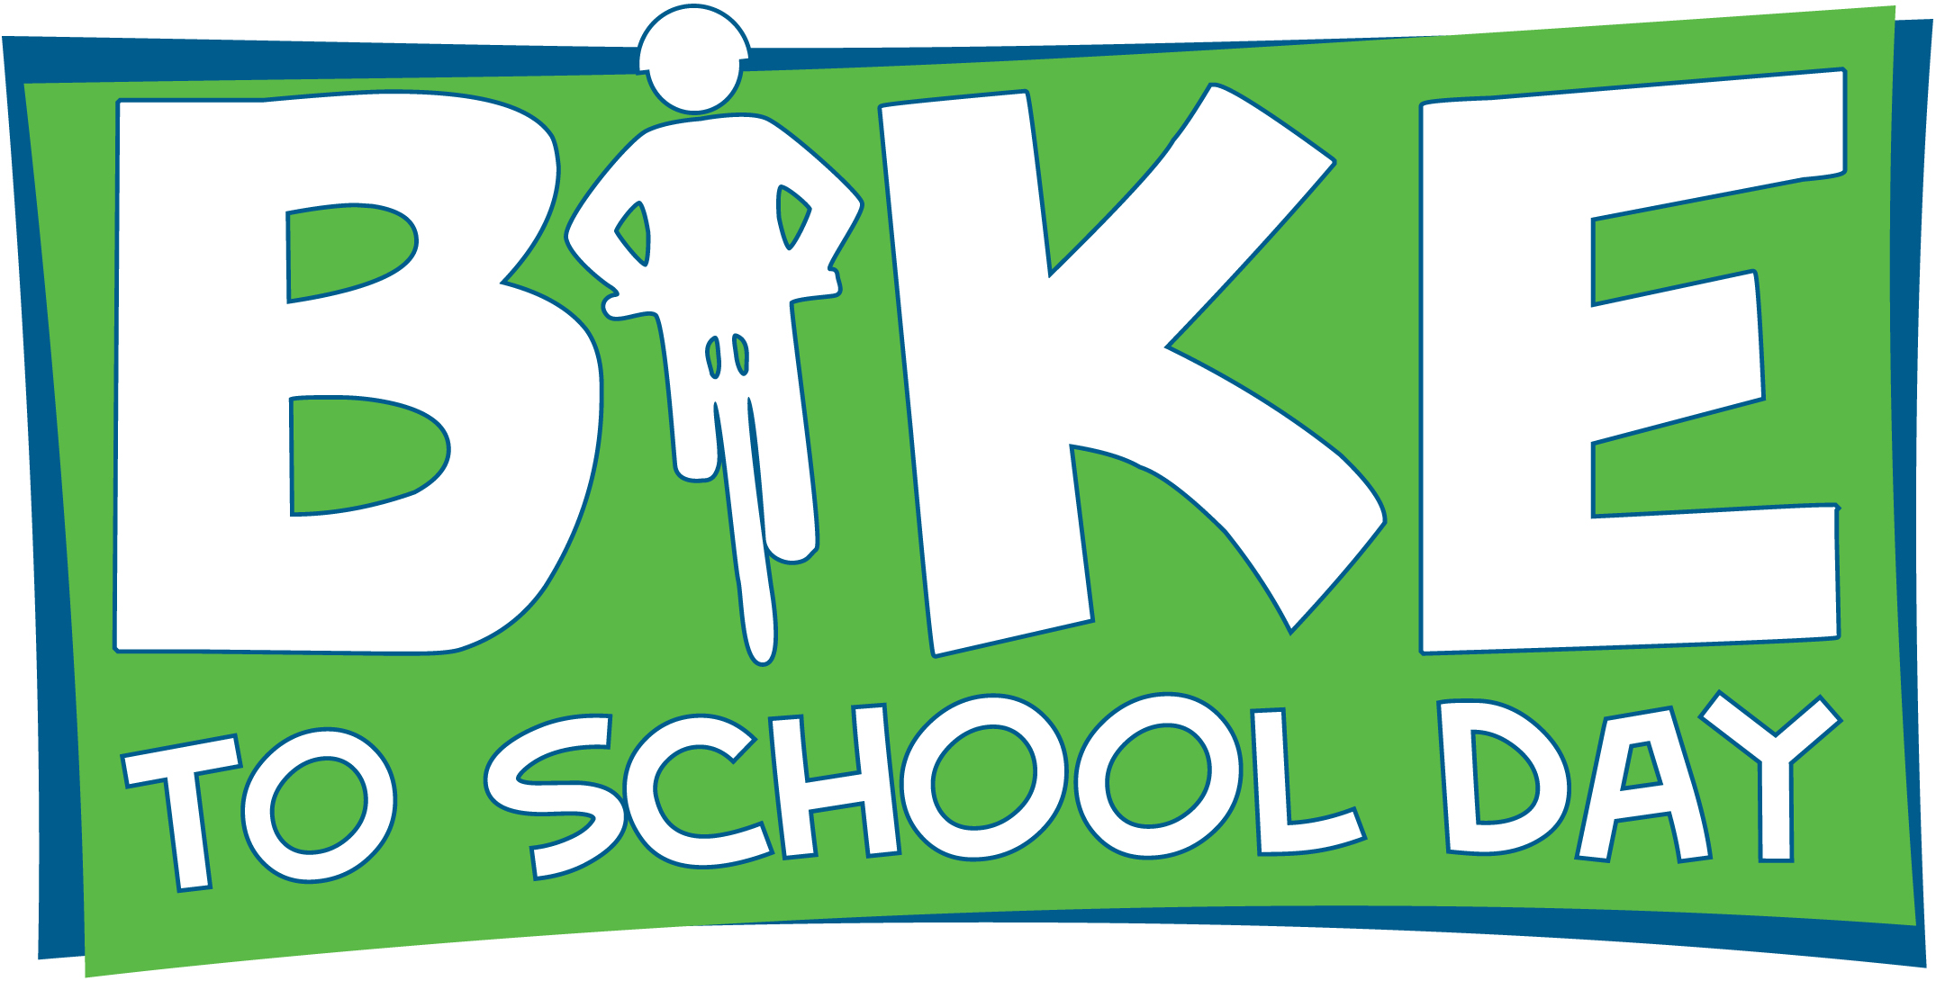
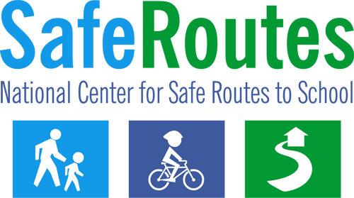

Bike to School Day News Release
The following news release template can be tailored to inform local media about Bike to School Day or other bike and walk to school events being organized throughout the year.

Using the Template

- Fill in the bracketed areas with your organization/event information and change type color to black.
- Logo: Use the Bike to School Day logo or replace it with your own program logo. You may want to print the news release on your organization’s letterhead.

- Contact Information: It is important to choose a point person for the news release who will be available once the release is distributed and throughout the event. Use the contact phone number that has the greatest likelihood of reaching the person.
- Length: The ideal news release is no longer than one page in length.
- Identify Media Contacts: Find tips on contacting the media at www.walkbiketoschool.org/get-set/promote-the-event/press-releases
- Distribution: A few days or the day before the event, distribute the release to local media contacts (television, radio, and newspaper) via email, mail or hand delivery.

- Materials: Have copies of the news release available at the event. In addition, you may also compile a press kit, including fact sheets, backgrounders and biographies.
.

Scroll down to page 2 to begin the news release.

FOR IMMEDIATE RELEASE  [Release date] |  | CONTACT: [Name] [Phone Number]  [Email Address]

[City, county, area] school(s) to celebrate
National Bike to School Day on [Month & Day]

[CITY, STATE] ([Date]) – [Name of school, participating organizations, etc.] in [city] will join schools from around the country to celebrate National Bike to School Day on [Month Day, Year].

Approximately [number] students will be riding or walking to school [day(s) of the week] along with parents, teachers and community leaders. [List any names and titles of participating community leaders or prominent figures].

The event will begin at [time] with kids, parents and community leaders riding from [start location]. Bicyclists and walkers will arrive at the school at [time]. Other special activities associated with the event include [list any additional event details such as giveaways, using a bikeability checklist or holding a pep rally].

Bike to School Day encourages a nationwide bike-focused celebration for students in the month of May and builds on the popularity and success of Walk to School Day, which is celebrated across the country – and the world – each October.

Bike to School Day events raise awareness of the need to create safer routes for bicycling and walking and emphasize the importance of issues such as increasing physical activity among children, pedestrian safety, reducing traffic congestion and concern for the environment. The events build connections between families, schools and the broader community.

The event is being organized by [organizing group(s)]. [Include information about your program and how it fits into the larger picture for the community, whether it is part of a Safe Routes to School program, etc.]

For additional local information, please contact [name] at [phone number that enables the media to contact the individual before and during the event].

For additional information, please visit these websites:

Walk and Bike to School Day www.walkbiketoschool.org
National Center for Safe Routes to School www.saferoutesinfo.org

###

About National Bike to School Day
National Bike to School Day, coordinated by the National Center for Safe Routes to School, provides an opportunity for communities across the country to join together to bicycle to school on the same day. The event builds on the excitement surrounding National Bike Month, led by the League of American Bicyclists each May, as well as the popularity of Walk to School Day, coordinated by the National Center for Safe Routes to School every October.

National Bike to School Day is based on the Walk to School Day model. Walk to School Day was founded in 1997 as a way to bring community leaders and children together to build awareness for communities to be more walkable. The one-day event has now grown to a month-long celebration with students and parents from more than 4,000 U.S. schools joining millions of Walk to School Day and Month participants worldwide. The reasons for walking have grown just as quickly as the event itself. For more information on bike and walk to school activities in the United States, visit www.walkbiketoschool.org.

About the National Center for Safe Routes to School
Established in May 2006, the National Center for Safe Routes to School assists states and communities in enabling and encouraging children to safely walk and bicycle to school. The National Center serves as the information clearinghouse for the federal Safe Routes to School program with funding from the U.S. Department of Transportation Federal Highway Administration. Part of the University of North Carolina Highway Safety Research Center, the National Center also provides technical support and resources and coordinates online registration efforts for U.S. Walk to School Day and facilitates worldwide promotion and participation. For more information, visit www.saferoutesinfo.org.

