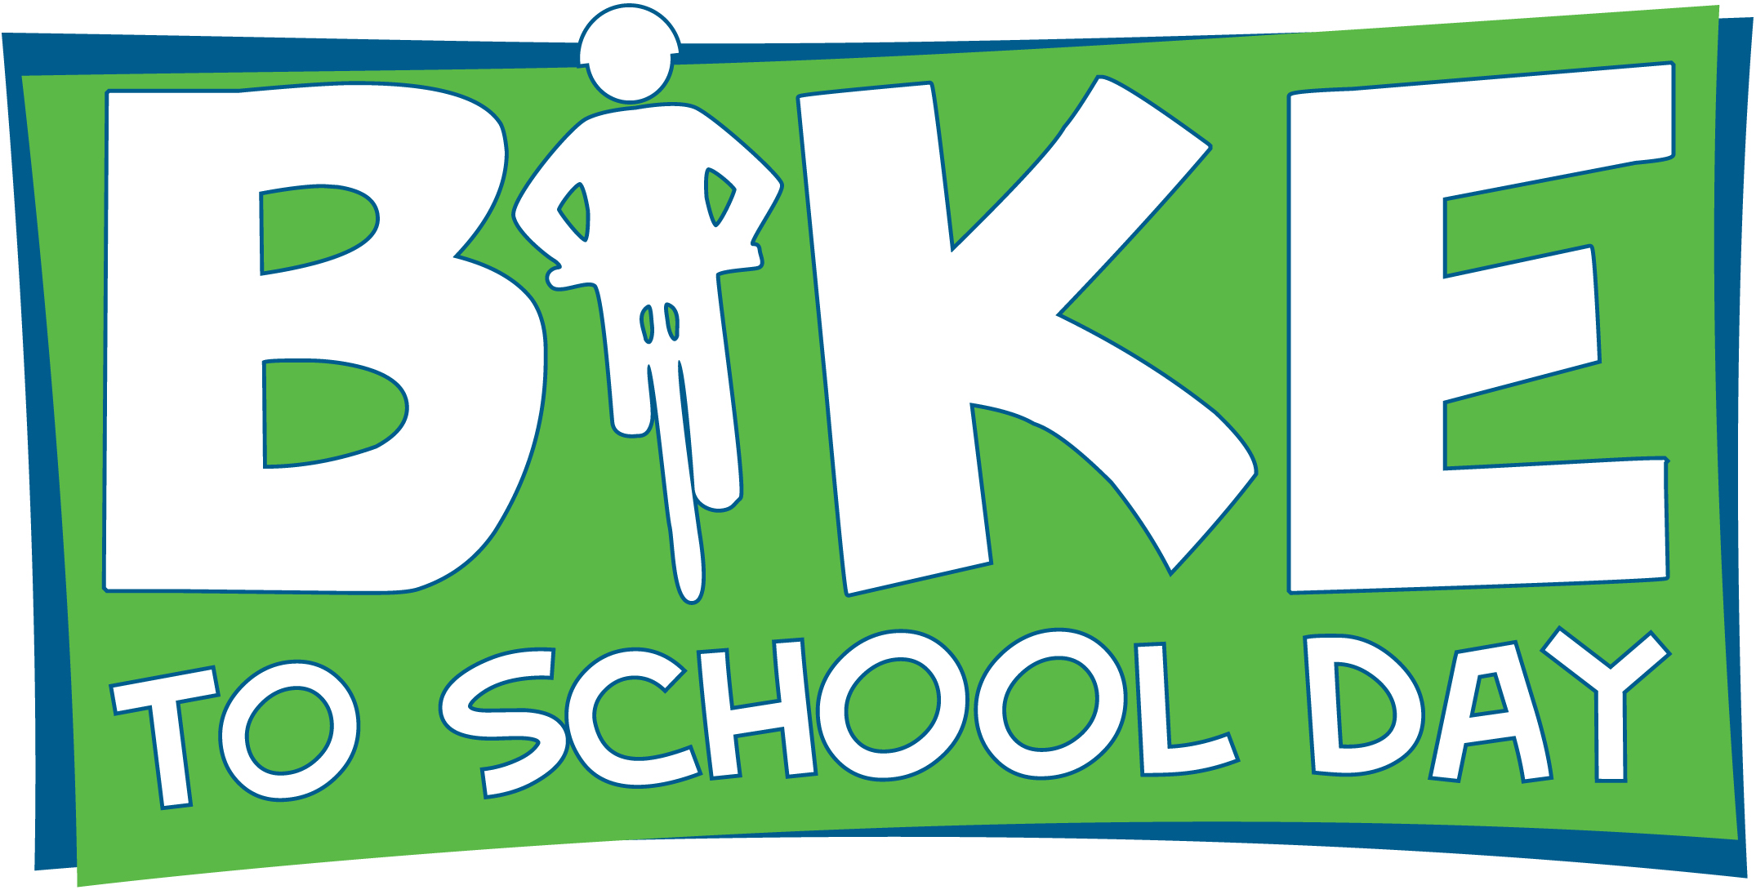
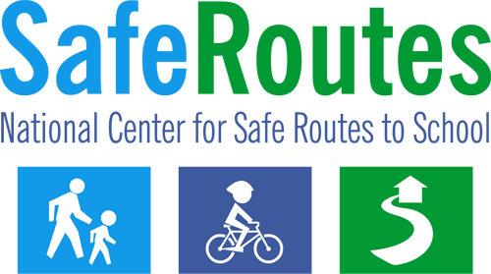

Bike to School Day Media Advisory
The following template media advisory can be tailored to give the media all of the general details of your Bike to School event – including the who, what, when, where and significance of your event.

Using the Template

- Fill in the bracketed areas with your organization/event information and change the type color to black.
- Logo: Please feel free to use the logo or replace it with your own program logo. You may also choose to print the news release on your organization’s letterhead.

- Contact Information: It is important to choose a point person for the media advisory who will be available as soon as the advisory is distributed and throughout the event. Use the contact and phone number that has the greatest likelihood of allowing the media to quickly reach the person.
- Identify Media Contacts: Find tips on contacting the media at www.walkbiketoschool.org/get-set/promote-the-event/press-releases

- Distribution: About 1-2 weeks prior to the event, distribute the media advisory to local media contacts (television, radio, and newspapers) that might be interested in covering a bike to school event. Email, mail and hand delivery are all good ways to distribute the release.

Scroll down to page 2 for the media advisory.

FOR IMMEDIATE RELEASE  [Release date] |  | CONTACT: [Name]  [Phone Number]  [Email Address]

[City, county, area] school(s) to celebrate
National Bike to School Day on May [day, year]

WHAT: [Name of school, participating organizations, etc.] in [city] will be joining schools from around the country to celebrate National Bike to School Day on May [day, year].

WHO: [Name(s) of schools participating]
[Name(s) of prominent community members participating]

WHERE: [location such as where bicyclists will meet to bike together, streets that children will be biking along, or school ending point. Include visual cues, e.g., next to the big oak tree.]

WHEN: [Time, i.e., Gather at 7 a.m., walk to begin at 7:15 a.m.]

SIGNIFICANCE: Approximately [number] students from [name of school(s) participating] will be biking to school along with parents, teachers and community leaders. [List any names and titles of participating community leaders or prominent figures].

Bicyclists from the across the United States will join together to celebrate National Bike to School Day. Bike to School events work to create safer routes for bicycling and walking, and emphasize the importance of a range of issues such as increasing physical activity among children, cyclist and pedestrian safety, traffic congestion, concern for the environment and building connections between families, schools and the broader community.

The event is being organized by [organizing group(s)]. [Include additional information about your program and how it fits into the larger picture for the community, whether it is part of a Safe Routes to School program, etc.]

For more information, visit:
National Bike to School Day www.walkbiketoschool.org
National Center for Safe Routes to School www.saferoutesinfo.org

###

